The Washtenaw Psychology Society
Presents
MPA is approved to sponsor continuing education for psychologists. MPA maintains responsibility for this program and its content.
Sponsored by the Washtenaw Psychological Society (WPS)
1 hour of free CE credit available for MPA members

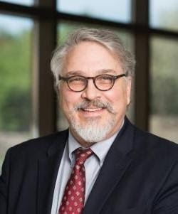

Nominated Support Team for Suicidal Young Adults: Community Collaboration in Outcome Research
By Todd K. Favorite, Scott Halpert, and Dr. Christal Eason

Sunday, July 18, 2021 from 2:00-3:30 pm

The presentation will focus on a feasibility study on the implementation of “Youth Support Team (YST)” intervention in a sample of young adults enrolled in Garrett’s Space, a community-based, wellness program. Participants will learn about the structure and development of the YST intervention and its empirical evidence for prevention, adaptions of YST for young adult populations at risk of suicide, and the background and program elements of the Garrett’s Space wellness program. Use this link to register for the event.

